Preparing the Board of Examiners Booklet

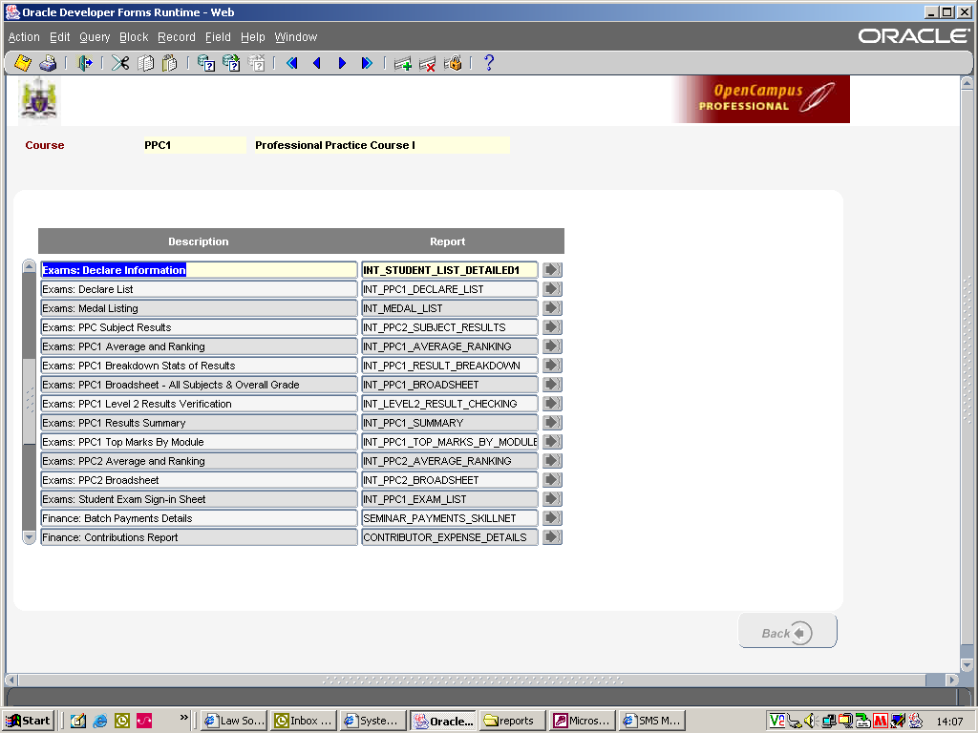

Report Order

- Exams: PPC1 Results Summary
- Exams: PPC1 Breakdown Stats of Results
- Exams: Medal Listing
- Exams: PPC1 Average and Ranking
- Exams: PPC Subject Results

Please find below information re the parameters you need to fill out when using the above reports.

Report 1 – Exams: PPC1 Results Summary

Sitting: select the exam sitting e.g. 1st Sitting

Board Date: enter in the date of the Board of Examiners Meeting e.g. 12/07/10

Starting Page No: enter the page number you would like on the bottom of the page so that a comprehensive index can be prepared for the booklet.

Report 2 – Exams: PPC1 Breakdown Stats of Results

Sitting: select the exam sitting e.g. 1st Sitting

Starting Page No: enter the page number you would like on the bottom of the page so that a comprehensive index can be prepared for the booklet.

Report 3 – Exams: Medal Listing

Please note – this report is course specific, so if no student in e.g. Cork won a prize the list will be blank.

Starting Page No: enter the page number you would like on the bottom of the page so that a comprehensive index can be prepared for the booklet.

Report 4 – Exams: PPC1 Average and Ranking

Sitting: select the exam sitting e.g. 1st Sitting

Board Date: enter in the date of the Board of Examiners Meeting e.g. 12/07/10

Starting Page No: enter the page number you would like on the bottom of the page so that a comprehensive index can be prepared for the booklet.

Result: if you leave this field blank it will show you all results. If you enter in e.g. Fail, the report will only print out the fail results. The filter options are as follows: Pass/Fail/Merit/Commendation/Absent/Deferred or leave blank and all results will appear.

Please note: The ranking will adjust in according to the filter option.

Report 5 – Exams: PPC Subject Results

Module: click on the “…” radio button beside the module field, select the module you require the information for. This report will only display module results for the Level 1 subjects. If you want to view the breakdown of the results for a level 2 subject e.g. Civil and Criminal Litigation you need to open up the Exams: PPC1 Level 2 Results Verification report.

Sitting: select the exam sitting e.g. 1st Sitting

Board Date: enter in the date of the Board of Examiners Meeting e.g. 12/07/10

Starting Page No: enter the page number you would like on the bottom of the page so that a comprehensive index can be prepared for the booklet.

Result: if you leave this field blank it will show you all results. If you enter in e.g. Fail, the report will only print out the fail results. The filter options are as follows: Pass/Fail/Merit/Commendation/Absent/Deferred or leave blank and all results will appear.

Please note: The ranking will adjust in according to the filter option.

The following reports are also available and could be used as part of the booklet.

Exams: PPC1 Broadsheet All Subjects & Overall Grade – you can view all subject results on a particular course.

Exams: PPC1 Top Marks By Module – you can view the top e.g. 10 students marks per module.

Exams: PPC1 Level 2 Results Verification – you can view all Level 2 results e.g. Civil and Criminal Litigation.

