PHOTO BRIEF for Events/Launches
Law Society of Ireland

Event name:
Contact(s):
Key Details (time, attendees, purpose):

Shot List Overview
- Preference for candid shots
- Minimise ‘shooting gallery’ photos – only take posed group line-ups as exception rather than the rule.
- Gender balance – not all men or all women! (where possible)
- Balance of age groups and diversity where possible
- Minimal shots with alcohol and compromising or unflattering shots
- Both landscape and portrait for flexibility on digital channels
- Inside and out for larger events
- Different angles, for example, from behind audience of speaker and attendees as well as from front of the audience, narrow speaker focus and wide-angle shots. Take generic shots of the environment and any event banners/logos – can be useful.
- Minimise external building shots so it’s not a default for stories or promotions – unless specifically relevant.
- Where appropriate, get and send some quick photos using mobile phone as well.

Key people, for example, the president, director general, directors, special guests, and keynote speakers
- Minimise photos of other staff unless directly related to the event (for example, speaker)

Schedule for event if relevant
- <details here>

Deadline for Photos

- Up to 6 images to be sent to contact immediately post-event for use on news/social media
- Other images as soon as possible thereafter via link to website, sent via email to event contact(s).
- If possible, take some of your own photos to share with the digital team on your phone.

Examples: These are guidelines to raise awareness of presenting a more modern, gender-balanced, less formal and less ‘stuffy’ profession and Law Society – where reasonable!

Do: Take more candid / ‘action-type’ photos | Minimise: Line-up photos (if possible)
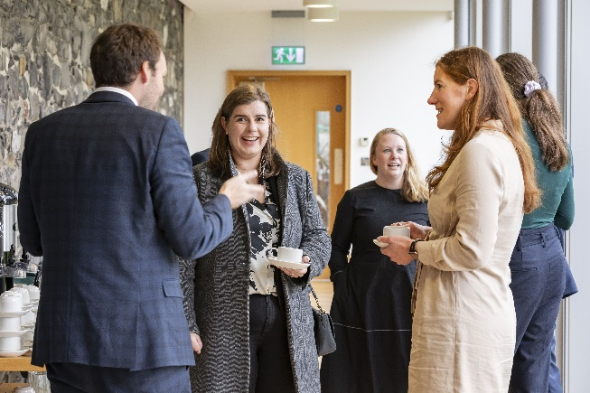 | 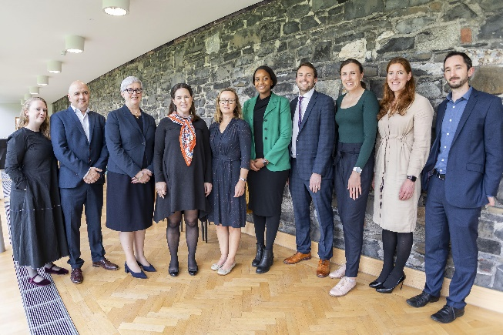
Do: Consider diversity and inclusion -gender, age, background | Minimise: One demographic– seek balance where possible
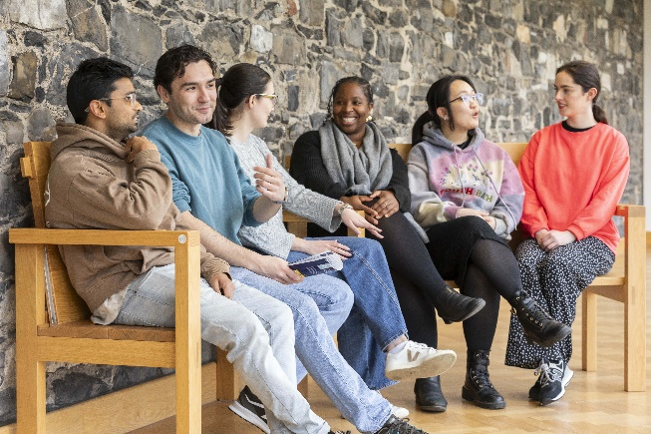 | 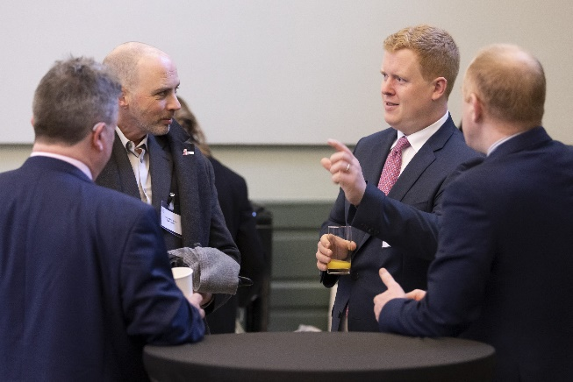
Do: Capture more candid shots of event attendees | Minimise: Alcohol, and avoid children
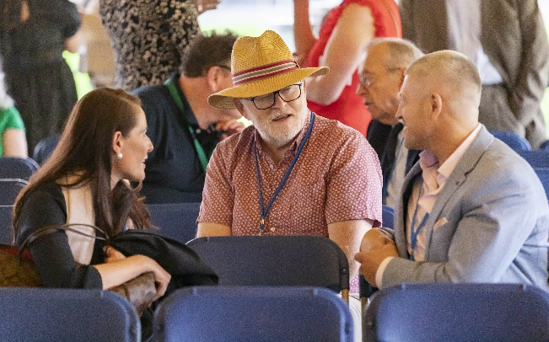 | 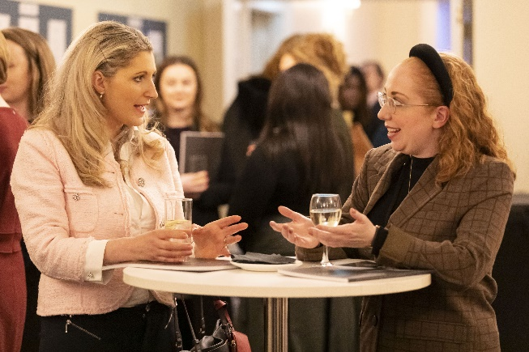
Do: Capture Law Society reps in variety of settings with focus on DG, Directors and President | Minimise: Photos of other Law Society staff for a shoot (unless relevant eg speaker at event)
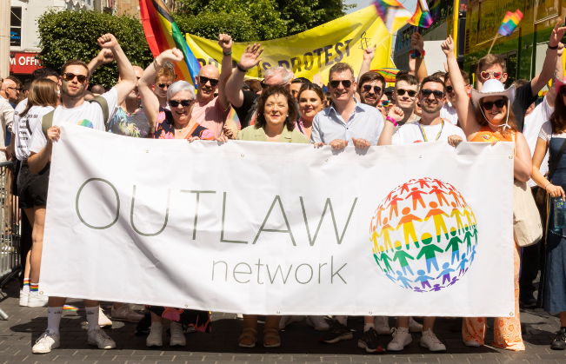 | 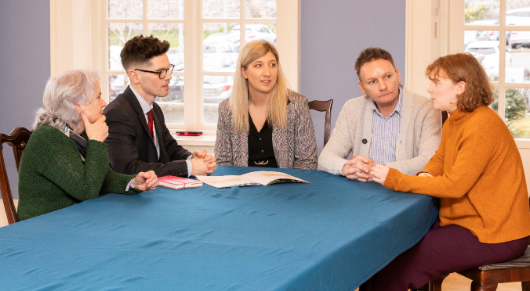
Do: Capture different angles/creative shots | Minimise: building only shots – (unless relevant or requested)
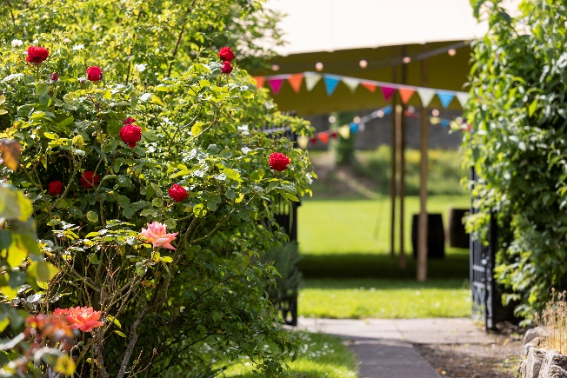 | 