Delimited Report
(a report that can be used in Excel)

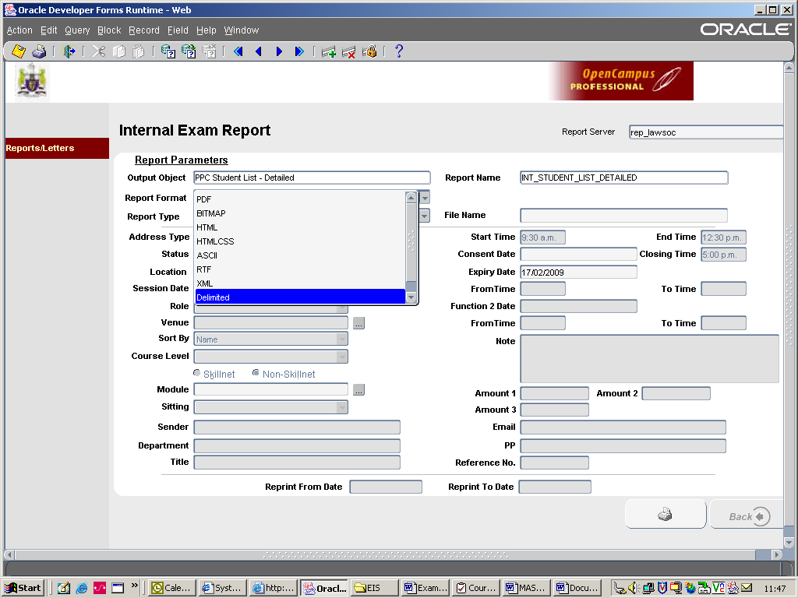

- Select the report as usual in EIS.
- Drop down the “Report Format” tab and select “Delimited” or “Delimited Large Files” (see above screen).
- Fill out required parameters e.g. enter expiry date, select module.
- Then click the “Print” icon.

A text file will open on top of existing screen.
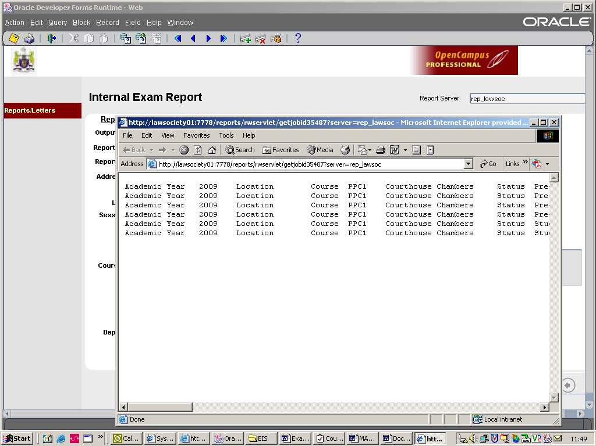

Click on “File” and then “Save As”. Cick on the “Save as type” option and select Text File [*.txt]. Save file in appropriate folder etc.

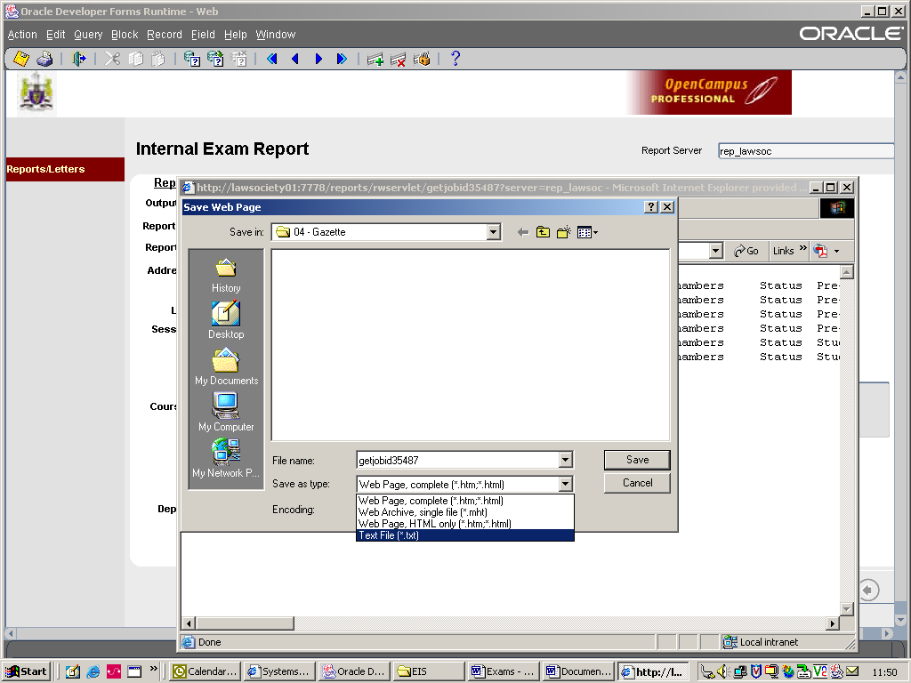

Open up Excel, File, Open, (find file). Remember the file type is a text file (.txt).
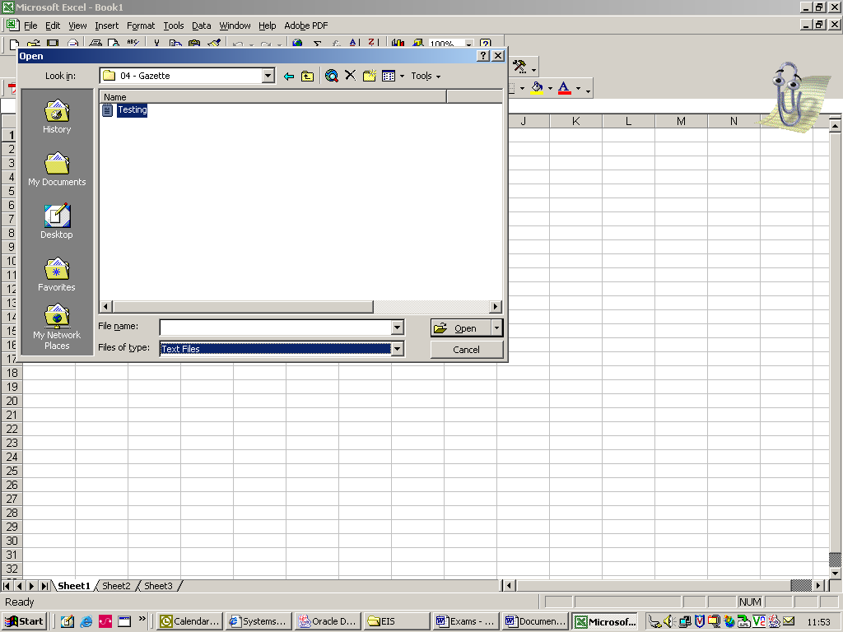

Double click to open, you will be brought into “Text Import Wizard” click next on all options and then finish.
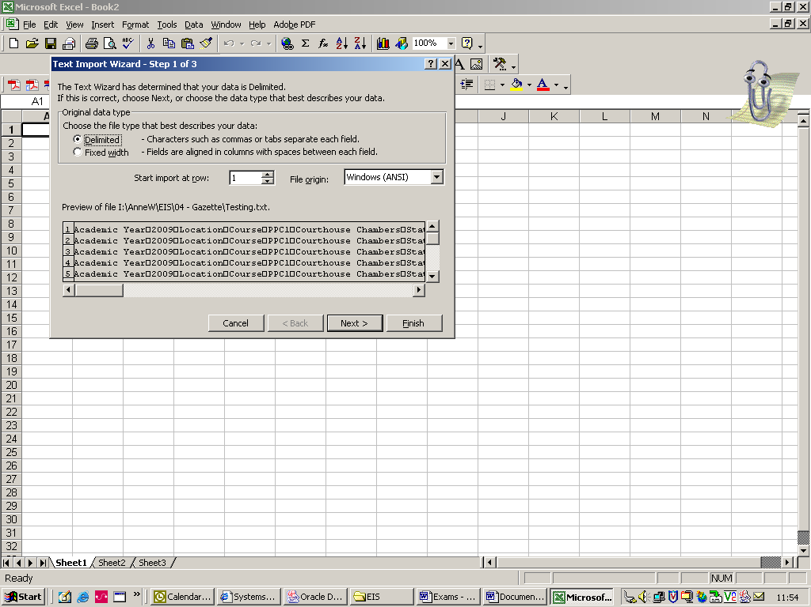

The file will open, you will need to delete surplus information from spreadsheet as txt files put the heading lines beside every entry.

