PPC1 - Available Exam Reports

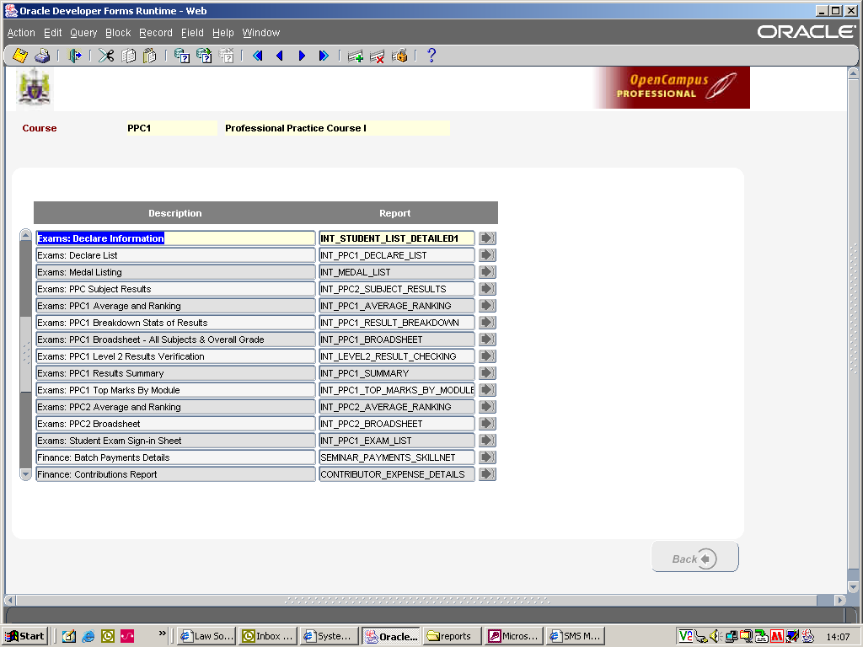

Top 8 PPC1 Exam Reports

- Exams: PPC1 Results Summary
- Exams: PPC1 Breakdown Stats of Results
- Exams: Medal Listing
- Exams: PPC1 Average and Ranking
- Exams: PPC Subject Results
- Exams: PPC Broadsheet All Subjects & Overall Grade
- Exams: PPC Top Marks By Module
- Exams: PPC1 Level 2 Results Verification

Basic Instruction for printing off reports
      - Go into the home screen for Courses, click on the reports tab (bottom left of the screen).
      - Then click “Courses”.
      - Adjust the session (year) as required and select the course e.g. 2009 PPC1 Dublin by clicking on the yellow folder beside your selection.
      - You will then be brought in to the parameter screen. Please find below information re the parameters you need to fill out when using the above reports.

Report 1 – Exams: PPC1 Results Summary

Sitting: select the exam sitting e.g. 1st Sitting (MANDATORY FIELD).

Board Date: enter in the date of the Board of Examiners Meeting e.g. 12/07/10 (for Exams use only).

Starting Page No: enter the page number you would like on the bottom of the page so that a comprehensive index can be prepared for a booklet, or leave blank if you don’t require page numbering.

Report 2 – Exams: PPC1 Breakdown Stats of Results

Sitting: select the exam sitting e.g. 1st Sitting (MANDATORY FIELD).

Starting Page No: enter the page number you would like on the bottom of the page so that a comprehensive index can be prepared for a booklet, or leave blank if you don’t require page numbering.

Report 3 – Exams: Medal Listing

Please note – this report is course specific, so if no student in e.g. Cork won a prize the list will be blank.

Starting Page No: enter the page number you would like on the bottom of the page so that a comprehensive index can be prepared for a booklet, or leave blank if you don’t require page numbering.

Report 4 – Exams: PPC1 Average and Ranking

Sitting: select the exam sitting e.g. 1st Sitting (MANDATORY FIELD).

Board Date: enter in the date of the Board of Examiners Meeting e.g. 12/07/10 (for Exams use only).

Starting Page No: enter the page number you would like on the bottom of the page so that a comprehensive index can be prepared for a booklet, or leave blank if you don’t require page numbering.

Result: if you leave this field blank it will show you all results. If you enter in e.g. Fail, the report will only print out the fail results. The filter options are as follows: Pass/Fail/Merit/Commendation/Absent/Deferred or leave blank and all results will appear.

Please note: The ranking will adjust in according to the filter option.

Report 5 – Exams: PPC Subject Results

Module: click on the “…” radio button beside the module field, select the module you require the information for. This report will only display module results for the Level 1 subjects. If you want to view the breakdown of the results for a level 2 subject e.g. Civil and Criminal Litigation you need to open up the Exams: PPC1 Level 2 Results Verification report (MANDATORY FIELD).

Sitting: select the exam sitting e.g. 1st Sitting (MANDATORY FIELD).

Board Date: enter in the date of the Board of Examiners Meeting e.g. 12/07/10 (for Exams use only).

Starting Page No: enter the page number you would like on the bottom of the page so that a comprehensive index can be prepared for a booklet, or leave blank if you don’t require page numbering.

Result: if you leave this field blank it will show you all results. If you enter in e.g. Fail, the report will only print out the fail results. The filter options are as follows: Pass/Fail/Merit/Commendation/Absent/Deferred or leave blank and all results will appear.

Report 6 – Exams: PPC Broadsheet All Subjects & Overall Grade

Sitting: select the exam sitting e.g. 1st Sitting (MANDATORY FIELD).

Board Date: enter in the date of the Board of Examiners Meeting e.g. 12/07/10 (for Exams use only).

Starting Page No: enter the page number you would like on the bottom of the page so that a comprehensive index can be prepared for a booklet, or leave blank if you don’t require page numbering.

Result: if you leave this field blank it will show you all results. If you enter in e.g. Fail, the report will only print out the fail results. The filter options are as follows: Pass/Fail/Merit/Commendation/Absent/Deferred or leave blank and all results will appear.

Report 7 – Exams: PPC Top Marks By Module

Module: click on the “…” radio button beside the module field, select the module you require the information for. This report will only display module results for the Level 1 subjects (MANDATORY FIELD).

Number to Display select the number of entries you want to display e.g. top 10 or top 21 ……. (MANDATORY FIELD).

Starting Page No: enter the page number you would like on the bottom of the page so that a comprehensive index can be prepared for a booklet, or leave blank if you don’t require page numbering.

Report 8 – Exams: PPC1 Level 2 Results Verification

Module: click on the “…” radio button beside the module field, select the module you require the information for. This report will only display module results for the Level 2 subjects e.g. Civil Litigation, Criminal Litigation, Skills etc (MANDATORY FIELD).

Sitting: select the exam sitting e.g. 1st Sitting (MANDATORY FIELD).

