Contributors Export

Step 1 - Micropay Export

Go into the contributors area on EIS
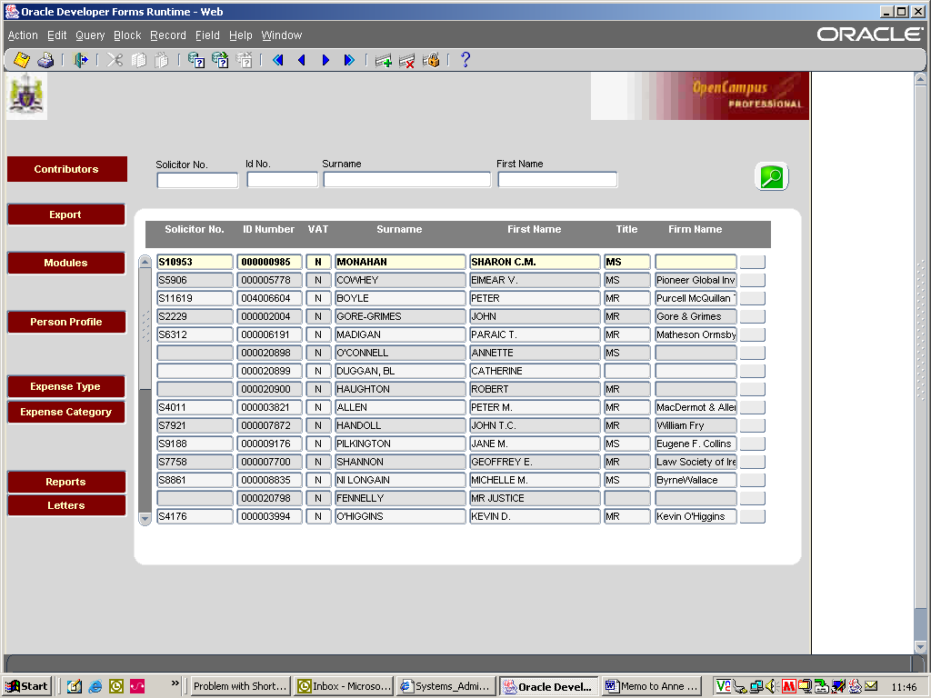

Click the Export radio button on the home screen. You will be brought into the following area.
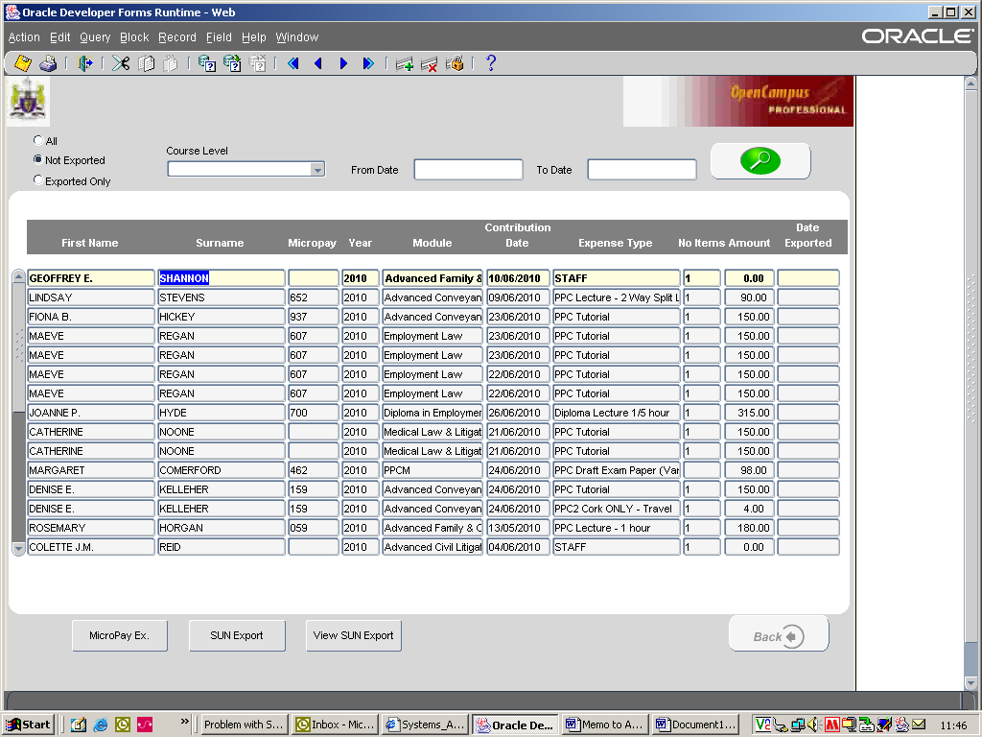

The Micropay export is worked at Course Level. You need to select the Course Level from the drop down menu eg PPC / Diploma / Extern_Exam (as at 1st July 2010). If additional course levels are added we will notify all teams involved.

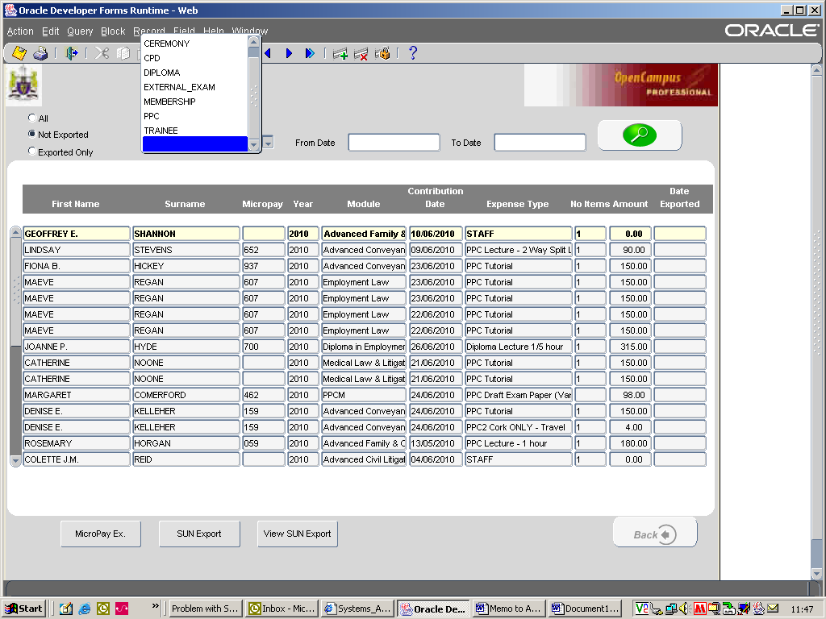

Once you’ve selected the course level, click on MicroPay Ex. radio button at the bottom of the screen.
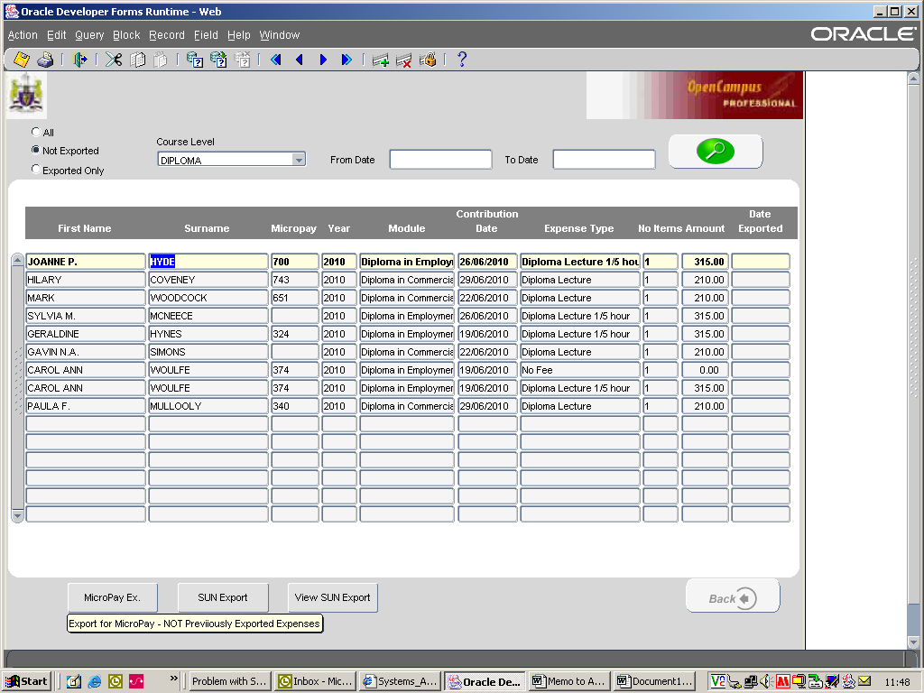

The following pop ups will appear – click OK.
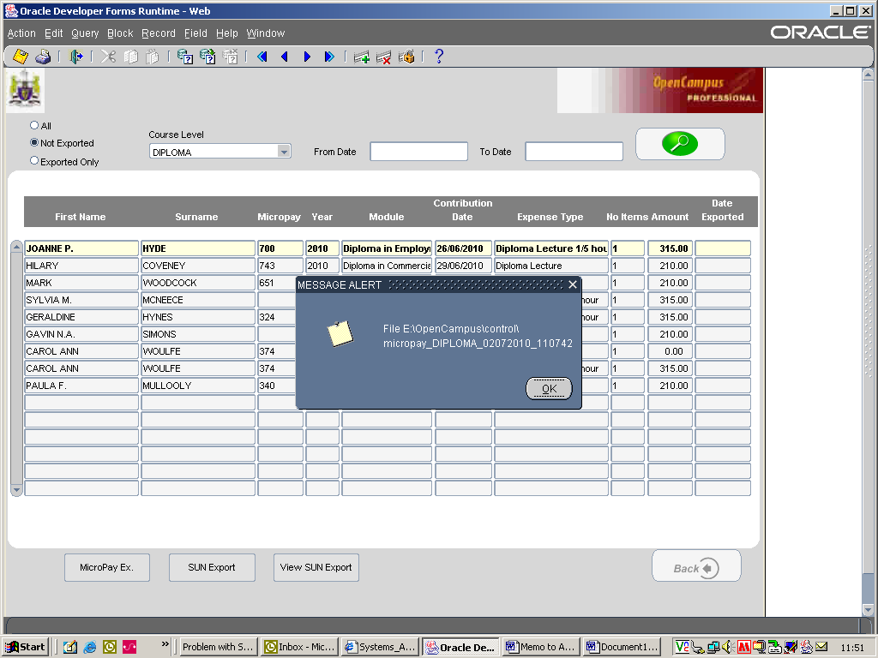
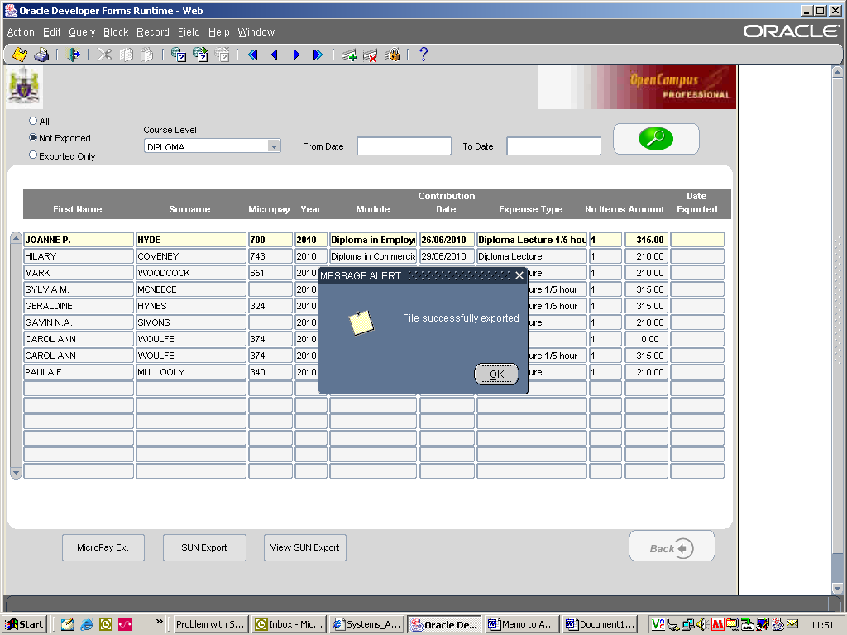

Your export for e.g. Diplomas has now been created. This file is located within the OpenCampus Law Society 01 drive, control directory - F:\control

Now the SUNExport needs to be created – see below Step 2.
Step 2 – SUN Export

This export is not defined by a course level. You just export all records sitting in the contributors area with no Micropay number.

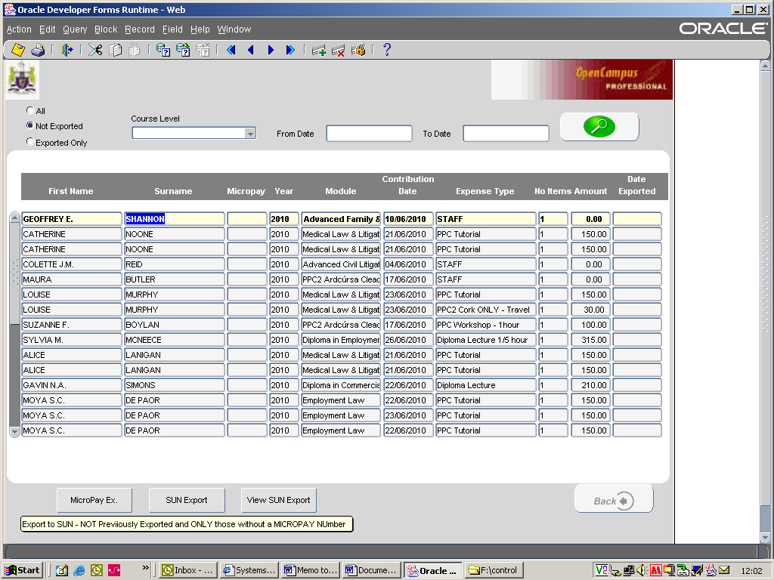

Click on the SUNExport radio button at the bottom of the screen. You are then brought into the screen below
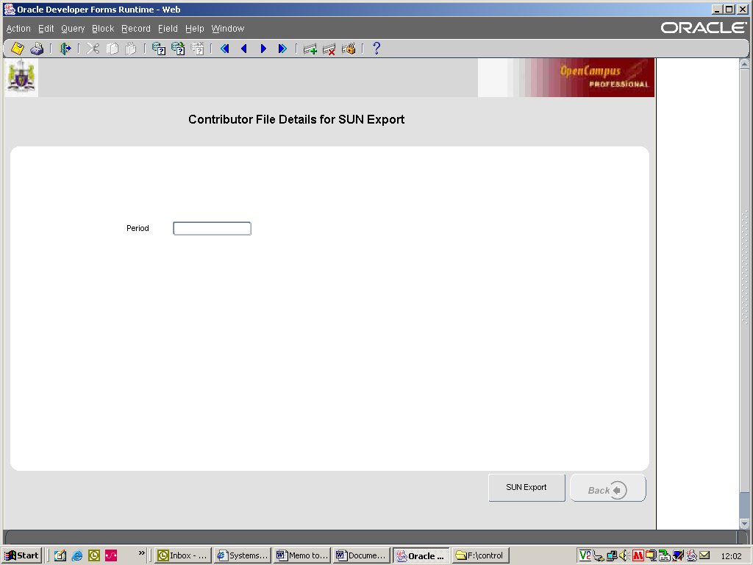

You need to check with accounts the accounting period e.g. July 007. You then need to enter in the following information 2010007 (year and then account period) and click on the SUNExport radio button. (this is a 7 character field so if the accounting period of November 011 you just enter in 2010011).

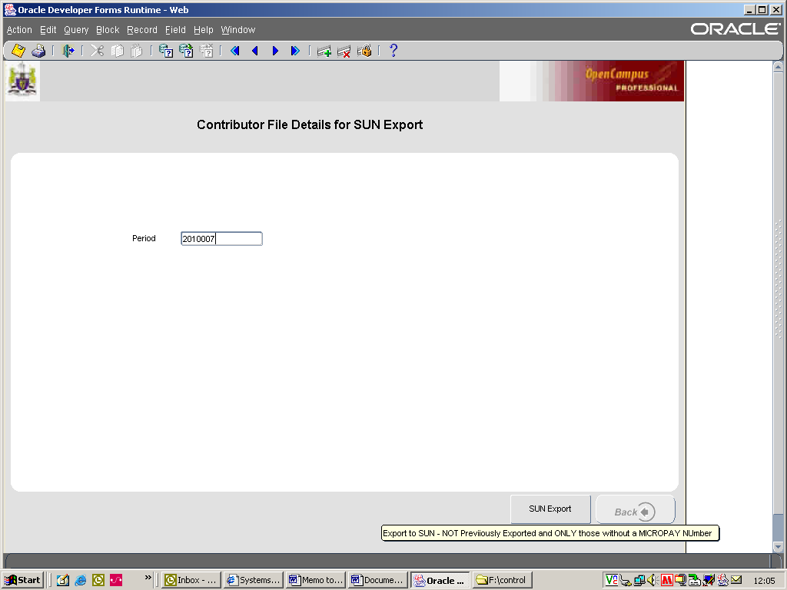

The following pop up screens will appear, click ok if required.
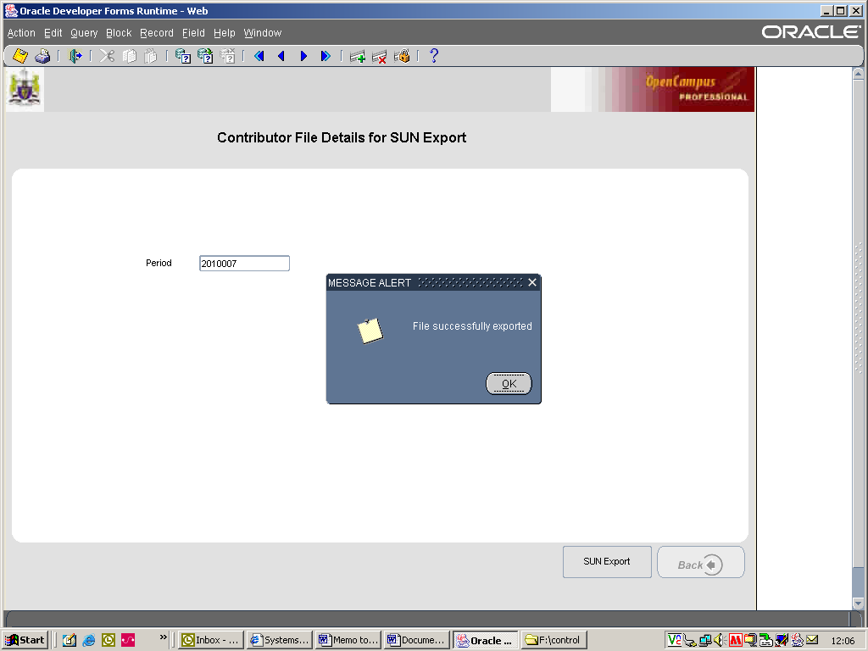

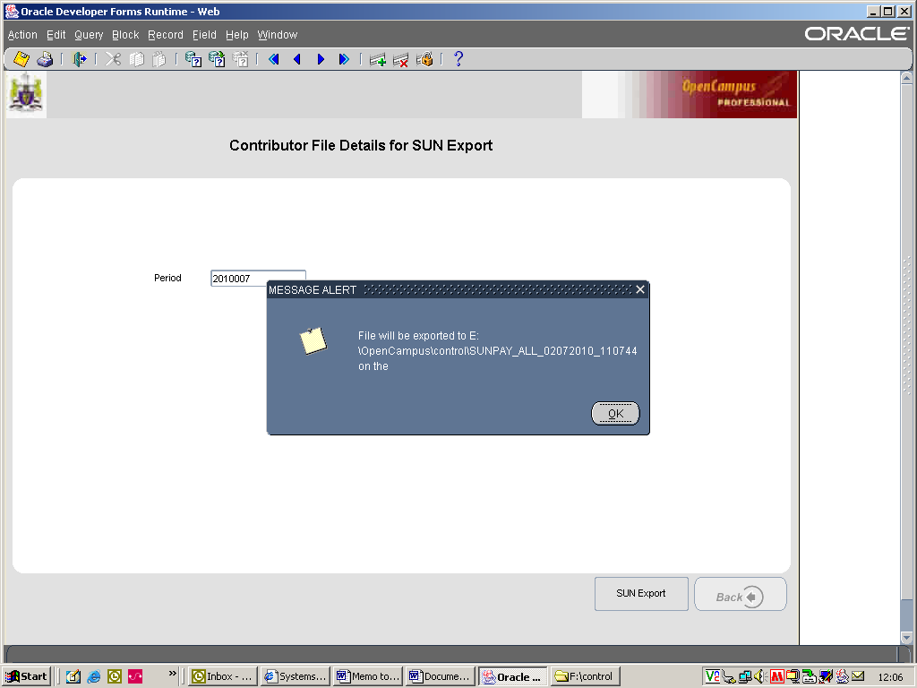

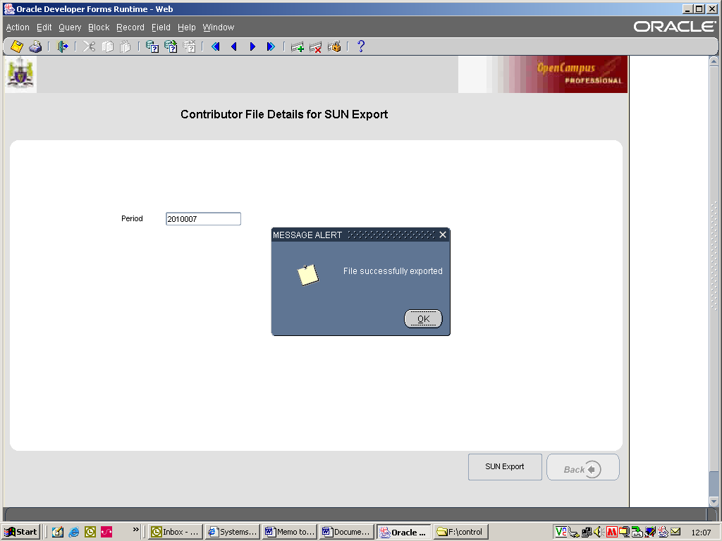
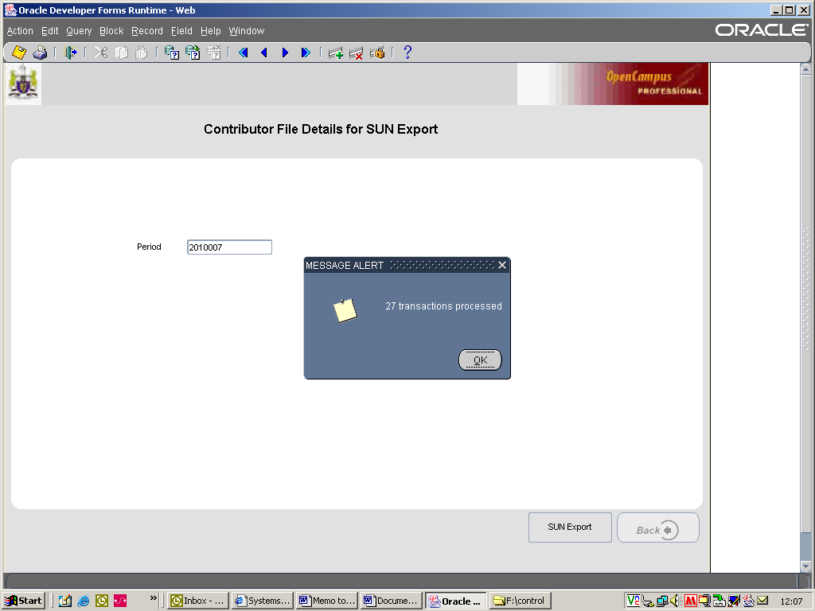

Your SUNExport has now been created. This file is located within the OpenCampus Law Society 01 drive, control directory - F:\control

Reports now need to be created and emailed to TP, Eddie, Pat, Oliver, Peggy, Anne etc.

REPORTS

Click the Report radio button on the home screen
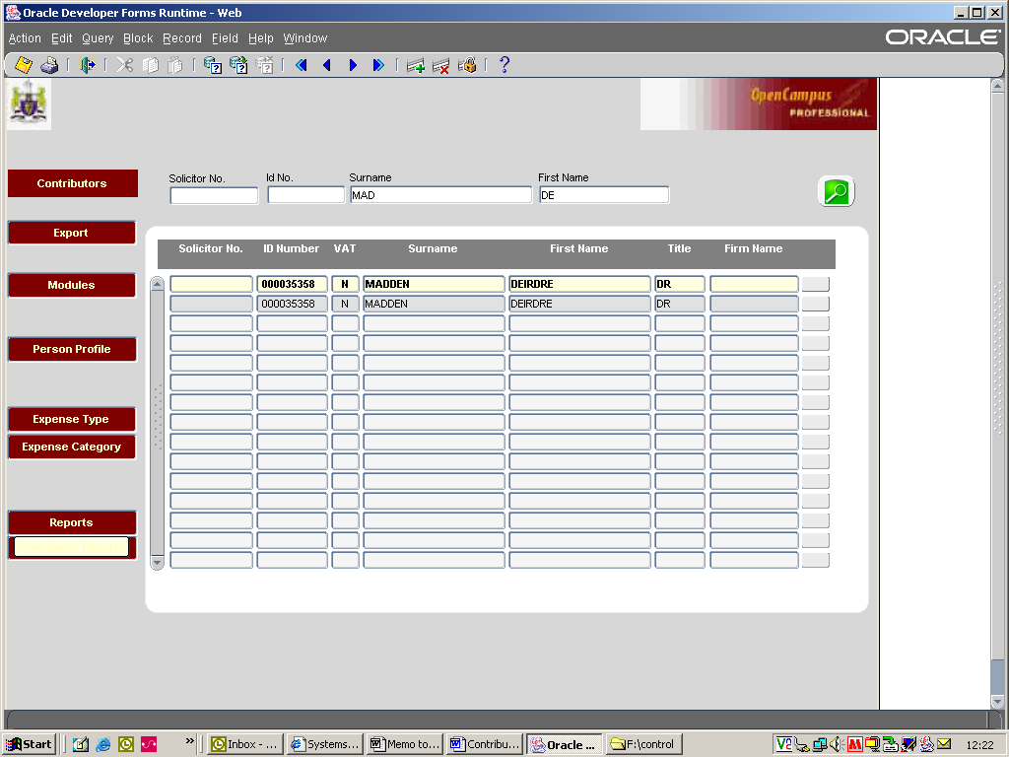

Select “Contributors Expenses Details” report.
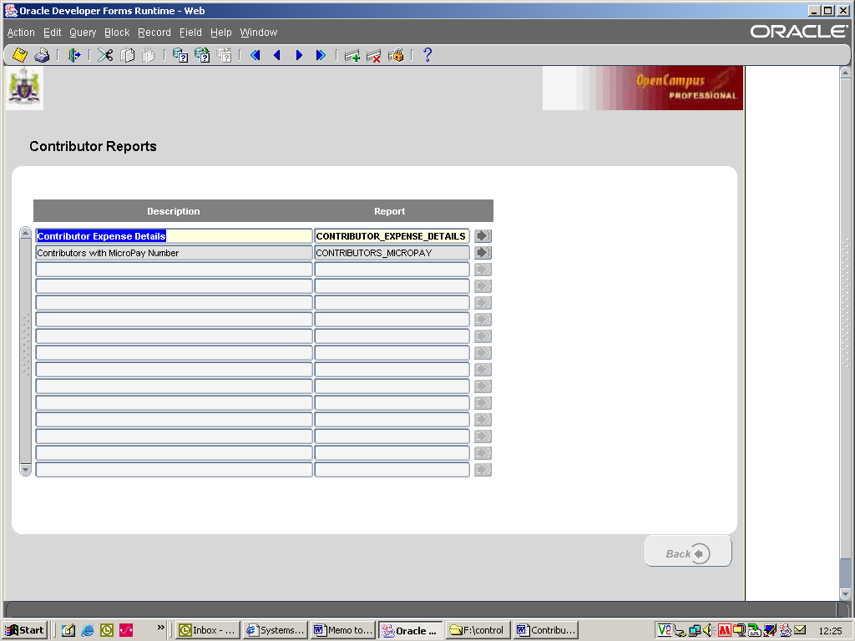

You are then brought into the parameter screen, you need to fill out the parameters as required.
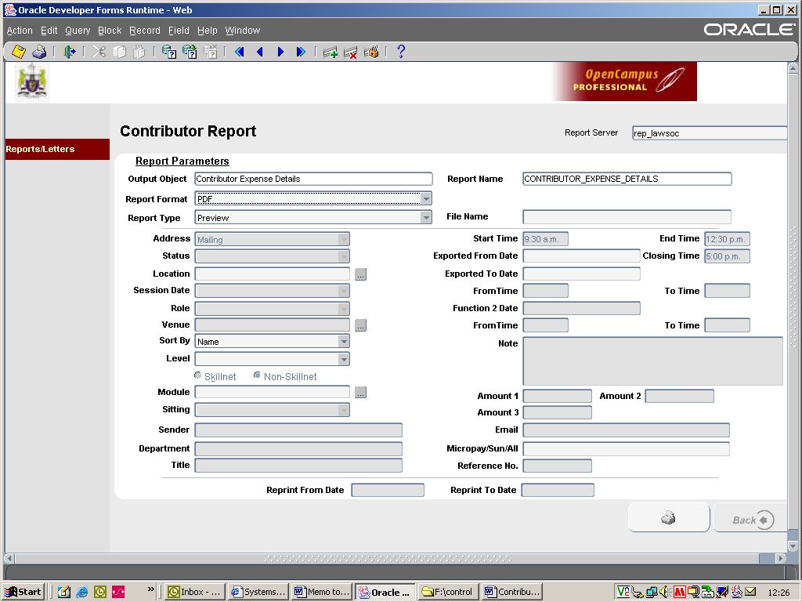

You need to extract 4-5 reports depending on course levels involved in the current export and save them in the following location
AnneW/EIS/Export Information/………….copy file names from previous exports.

The 4 or 5 reports required are as follows.

Report 1. PPC Dublin and Cork Contributor Export Information

The following parameters need to be filled out to get this report.

Level – select PPC
Export From Date – date of export e.g. today’s date (02/07/10)
Export To Date – same as above (02/07/10)
Micropay/Sun/All – type ALL

Click on the print radio button.

You need to save this report as EXPORT 020710 - PPC DUBLIN and CORK

Actual Date of export e.g. 020710

Report 2. PPC Cork Contributor Export Information

The following parameters need to be filled out to get this report.

Location – for Cork (select Courthouse Chambers)
Level – select PPC
Export From Date – date of export e.g. today’s date (02/07/10)
Export To Date – same as above (02/07/10)
Micropay/Sun/All – type ALL

Click on the print radio button.

You need to save this report as EXPORT 020710 - PPC CORK

Actual Date of export e.g. 020710

Report 3. PPC Dublin Contributor Export Information

The following parameters need to be filled out to get this report.

Location – for Dublin (select Blackhall)
Level – select PPC
Export From Date – date of export e.g. today’s date (02/07/10)
Export To Date – same as above (02/07/10)
Micropay/Sun/All – type ALL

Click on the print radio button.

You need to save this report as EXPORT 020710 - PPC DUBLIN

Actual Date of export e.g. 020710

Report 4. Diploma Export Information (if applicable)

The following parameters need to be filled out to get this report.

Level – select Diploma
Export From Date – date of export e.g. today’s date (02/07/10)
Export To Date – same as above (02/07/10)
Micropay/Sun/All – type ALL

Click on the print radio button.

You need to save this report as EXPORT 020710 - DIPLOMA

Actual Date of export e.g. 020710

Report 5. Extern_Exams Export Information (if applicable)

The following parameters need to be filled out to get this report.

Level – select Extern_Exams
Export From Date – date of export e.g. today’s date (02/07/10)
Export To Date – same as above (02/07/10)
Micropay/Sun/All – type ALL

Click on the print radio button.

You need to save this report as EXPORT 020710 – FE1’s

Actual Date of export e.g. 020710

EMAIL

Once all of the reports have been created you need to send the following email

To: TP, Eddie, Pat, Oliver, Peggy, Anne

Subject: Export – (enter export date e.g. 21st July 2010)

Email Text: (see below)
EXPORT TOTALS = PPC €??? (check PPC Dublin and Cork report, last page for amount) and Diplomas €?? (check Diploma report, last page for amount if applicable) and FE1’s €?? (check FE1’s report, last page for amount if applicable)

Hi Peggy

Please find attached the MICROPAY export for the ??/??/???? (enter date of export).

PPC Micropay = €????? (check PPC Dublin & Cork report Micropay total – these reports are split into Micropay and Non Micropay).
Diplomas Micropay = €????? (check relevant reports)
FE1’s Micropay = €????? (check relevant reports)

(attach the MICROPAY reports stored in the OpenCampus control directory.

Hi Pat

Please find attached the SUN FILE for the (enter the date of export) (if you have any queries, please do not hesitate to contact me @ 4951)

PPC SUN (non micropay) = €????? (check PPC Dublin & Cork report Non Micropay total – these reports are split into Micropay and Non Micropay).
Diplomas SUN (non micropay) = €????? (check relevant reports)
FE1’s SUN (non Micropay) = €????? (check relevant reports)

(attach the SUN report stored in the OpenCampus control directory

Hi TP and Edward

Please find attached the required reports for the above exports.

(attach the above 4 or 5 reports you saved to AnneW/EIS/Export Information).

Regards

YOU’VE NOW COMPLETED THE ENTIRE CONTRIBUTOR EXPORT PROCESS – HAPPY DAYS!!!!!!! ☺

